Preparation of Papers for the Smart Life 2017
First A. Author*, Second B. Author**, Jr., and Third C. Author
Affiliation-1*, Affiliation-2**
Abstract—These instructions give you guidelines for preparing papers for the Journal of Optical Communications and Networking, a joint publication from The Optical Society (OSA) and IEEE. Use this document as a template if you are using Microsoft Word. Otherwise, use this document as an instruction set. The electronic file of your paper will be formatted further at OSA. Define all symbols used in the abstract. Do not cite references in the abstract. Do not delete the blank line immediately above the abstract; it sets the footnote at the bottom of this column.

Index Terms—About four key words or phrases in alphabetical order, separated by semicolons. For a list of suggested keywords, send a blank e-mail to keywords@ieee.org or visit
http://www.ieee.org/organizations/pubs/ani_prod/keywrd98.txt

T

Introductiion
his document is a template for Microsoft Word versions 6.0 or later. If you are reading a paper or PDF version of this document, please download the electronic file, JOCN_template.doc, from Optics InfoBase at http://www.opticsinfobase.org/jocn/journal/jocn/author.cfm, so you can use it to prepare your manuscript. If you would prefer to use LATEX, download JOCN’s LATEX style and sample files from the same Web page. Use these LATEX files for formatting, but please follow the instructions in JOCN_template_2010.doc.
When you open JOCN_template.doc, select “Print Layout” from the “View” ribbon (View |Print Layout), which allows you to see the footnotes. Then, type over sections of JOCN_template.doc or cut and paste from another document and use markup styles. To access the Styles menu, click on the expansion arrow at the far right bottom of the Styles section of the “Home” ribbon. Highlight a section that you want to designate with a certain style, then select the appropriate name on the style menu. All the JOCN styles are labeled as such. The style will adjust your fonts and line spacing. Do not change the font sizes or line spacing to squeeze more text into a limited number of pages. Use italics for emphasis; do not underline.
To insert images in Word, position the cursor at the insertion point and either use Insert | Picture | From File or copy the image to the Windows clipboard and then Edit | Paste Special | Picture (with “float over text” unchecked).
OSA will do the final formatting of your paper.

Paper Submission Information
OSA manages the peer review and production processes for JOCN. All submissions to the journal must be completed electronically via OSA’s online JOCN peer review system. Instructions on preparing and uploading your manuscript can be found at
http://www.opticsinfobase.org/jocn/journal/jocn/author.cfm. If you have any questions after reviewing the materials please contact the JOCN Peer Review Office at jocn@osa.org.
Undecipherable English is a valid reason for rejection. Authors of papers rejected for this reason may revise and resubmit them to the Journal of Optical Communications and Networking after the English usage issues have been addressed.

Copyright Form
The online submission system allows for electronic transfer of copyright. It is not necessary to submit a paper copyright transfer agreement after completing the transfer online. If the copyright transfer must be approved by an authorized agent other than the submitting author, please download the OSA copyright form from the JOCN website, http://www.opticsinfobase.org/jocn/submit/review/copyright_permissions.cfm.
Authors are responsible for obtaining any security clearances prior to submission. Authors should also obtain permission to reproduce previously published content, such as figures or tables, if applicable. Please contact the JOCN Peer Review Office with any questions, jocn@osa.org.

Publication Charges
TABLE I
Units for Magnetic Properties
Symbol | Quantity | Conversion from Gaussian and  CGS EMU to SIª
Φ | Magnetic flux | 1 Mx → 10⁻⁸ Wb = 10⁻⁸ V·s
B | Magnetic flux density, magnetic induction | 1 G → 10⁻⁴ T = 10⁻⁴ Wb/m²
H | Magnetic field strength | 1 Oe → 10³/(4π) A/m
m | Magnetic moment | 1 erg/G = 1 emu  → 10⁻³ A·m² = 10⁻³ J/T
M | Magnetization | 1 erg/(G·cm³) = 1 emu/cm³  → 10³ A/m
4πM | Magnetization | 1 G → 10³/(4π) A/m
σ | specific magnetization | 1 erg/(G·g) = 1 emu/g → 1 A·m²/kg
j | Magnetic dipole  moment | 1 erg/G = 1 emu  → 4π × 10⁻¹⁰ Wb·m
J | Magnetic polarization | 1 erg/(G·cm³) = 1 emu/cm³  → 4π × 10⁻⁴ T
χ, κ | Susceptibility | 1 → 4π
χ_{ρ} | Mass susceptibility | 1 cm³/g → 4π × 10⁻³ m³/kg
μ | Permeability | 1 → 4π × 10⁻⁷ H/m  = 4π × 10⁻⁷ Wb/(A·m)
μ_{r} | Relative permeability | μ → μ_{r}
w, W | Energy density | 1 erg/cm³ → 10⁻¹ J/m³
N, D | Demagnetizing factor | 1 → 1/(4π)
ªGaussian units are the same as cgs emu for magnetostatics; Mx = maxwell, G = gauss, Oe = oersted; Wb = weber, V = volt, s = second, T = tesla, m = meter, A = ampere, J = joule, kg = kilogram, H = henry.

There are no obligatory publication charges for JOCN articles that do not exceed 10 pages. Articles that are 11-15 pages will incur charges of $220 per page for pages 11-15. Articles that exceed 15 pages will not be published unless prior approval is obtained from the Editors-in-Chief.

Preparation of Paper
This template serves as a guideline for preparing your paper. Additional formatting will be done during the production process if your paper is accepted for publication.

Figures and Tables
Because OSA will do the final formatting of your paper, you do not need to position figures and tables at the top and bottom of each column. In fact, all figures, figure captions, and tables can be placed at the end of the paper. Large figures and tables may span both columns. Place figure captions below the figures and place table titles above the tables. If your figure has two parts, include the labels “(a)” and “(b)” as part of the artwork. Please verify that the figures and tables you mention in the text actually exist. Please do not include captions as part of the figures. Do not put captions in “text boxes” linked to the figures. Do not put borders around the outside of your figures. Use the abbreviation “Fig.” within a sentence, but spell out “Figure” at the beginning of a sentence. Do not abbreviate “Table.” Tables are numbered with Roman numerals.
Figure axis labels are often a source of confusion. Use words rather than symbols. As an example, write the quantity “Magnetization,” or “Magnetization M,” not just “M.” Put units in parentheses. Do not label axes only with units. As in Fig. 1, for example, write “Magnetization (A/m),” not just “A/m.” Do not label axes with a ratio of quantities and units. For example, write “Temperature (K),” not “Temperature/K.”
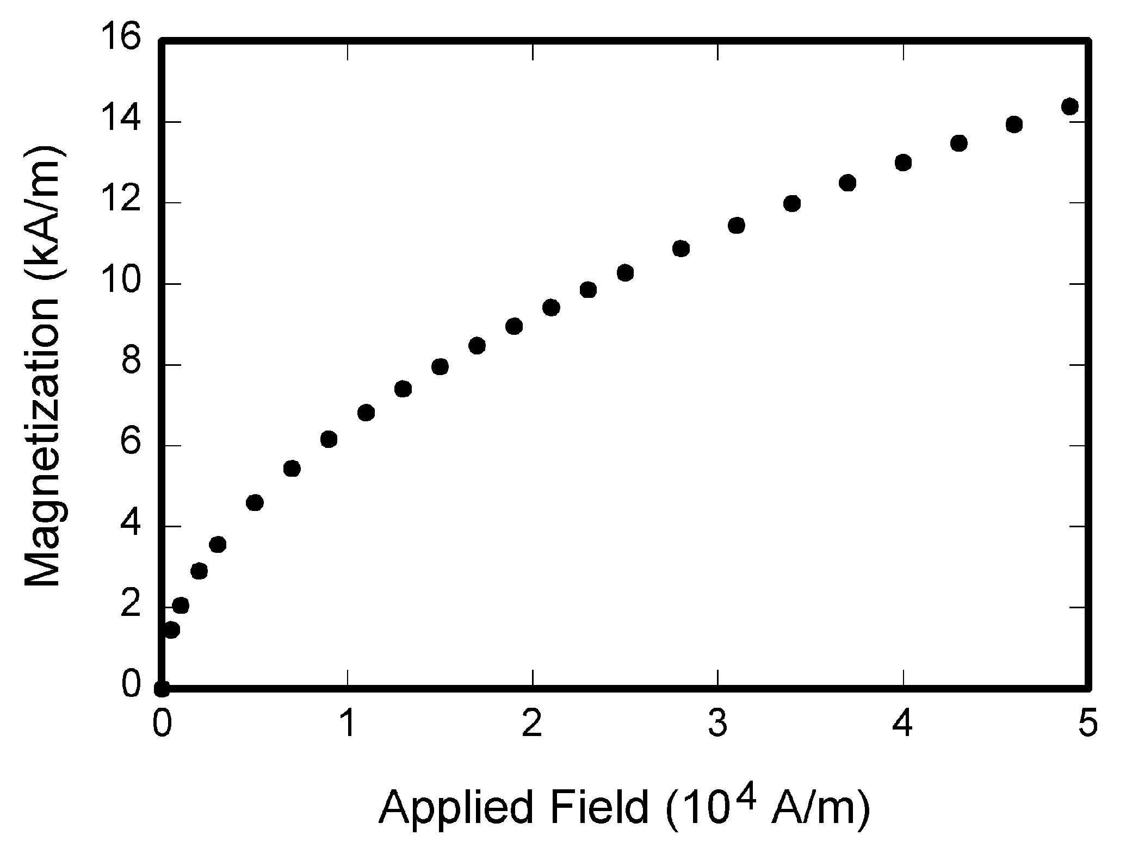
Fig. 1. Magnetization as a function of applied field. Note that “Fig.” is abbreviated. There is a period after the figure number. It is good practice to explain the significance of the figure in the caption.

Multipliers can be especially confusing. Write “Magnetization (kA/m)” or “Magnetization (10³ A/m).” Do not write “Magnetization (A/m) × 1000” because the reader would not know whether the top axis label in Fig. 1 meant 16000 A/m or 0.016 A/m. Figure labels should be legible, approximately 8 to 12 point type.

Electronic Image Files
Format and save your graphic images using a suitable graphics processing program that will allow you to create the images as Encapsulated PostScript (EPS) or Tagged Image File Format (TIFF), size them, and adjust the resolution settings.
Image quality is very important to how your graphics will reproduce. Even though we can accept graphics in many formats, we cannot improve your graphics if they are poor quality when we receive them. If your graphic looks low in quality on your printer or monitor, please keep in mind that we cannot improve the quality after submission.
If you are preparing images in TIFF or EPS format, note the following: High-contrast line figures and tables should be prepared with 600 dpi resolution and saved with no compression, 1 bit per pixel (monochrome), with file names in the form of “fig3.tif” or “table1.tif.” You do not need to submit tables as image files unless there are graphics within the tables. Please do not make algorithms into numbered figures; type them in as text.
Photographs and grayscale figures should be prepared with 600 dpi resolution and saved with no compression, 8 bits per pixel (grayscale).

Web Color Graphics
OSA accepts color graphics in the following formats: EPS and TIFF. The resolution of an RGB color TIFF file should be at least 300 dpi.
Your color graphic will be printed in grayscale. If a graphic is to appear online in color, it should be submitted as RGB color.

Sizing of Graphics
Most charts, graphs and tables are one column wide (3 1/4 inches or 19 1/2 picas) or two-column width (5 3/4 inches or 35 picas wide). We recommend that you avoid sizing figures less than one column wide, as extreme enlargements may distort your images and result in poor reproduction. Therefore, it is better if the image is slightly larger, as a minor reduction in size should not have an adverse affect on the quality of the image.

Size of Author Photographs
The final printed size of an author photograph is exactly 1 inch wide by 1 1/4 inches long (6 picas × 7 1/2 picas). Please ensure that the author photographs you submit are proportioned similarly.

Math
If you are using Word, use either the Microsoft Equation Editor or the MathType add-on (http://www.mathtype.com) to insert equations in your paper (Insert | Object | Create New | Microsoft Equation or MathType Equation). “Float over text” should not be selected.
Number equations consecutively with equation numbers in parentheses flush with the right margin, as in Eq. (1). First use the equation editor to create the equation. Then select the “Equation” markup style. Press the tab key and write the equation number in parentheses. To make your equations more compact, you may use the solidus ( / ), the exp function, or appropriate exponents. Use parentheses to avoid ambiguities in denominators. Punctuate equations when they are part of a sentence, as in

(1)

Be sure that the symbols in your equation have been defined before the equation appears or immediately following. Italicize symbols (T might refer to temperature, but T is the unit tesla). Refer to “Eq. (1),” except at the beginning of a sentence: “Equation (1) is ....”

References
Number citations consecutively in square brackets [1]. The sentence punctuation follows the brackets [2]. Multiple references [2,3] are numbered within one set of brackets. A consecutive series of references [1–3] is numbered within one set of brackets with an en dash between the first and last reference number. When citing a section in a book, please give the relevant page numbers [2]. In sentences, refer simply to the reference number, as in [3]. Do not use “Ref. [3]” or “reference [3]” except at the beginning of a sentence: “Reference [3] shows ....” Please do not use automatic endnotes in Word, rather, type the reference list at the end of the paper using the “References” style.
Number footnotes separately in superscripts (Insert | Footnote). Place the actual footnote at the bottom of the column in which it is cited; do not put footnotes in the reference list (endnotes). Use letters for table footnotes (see Table I).
Please note that the references at the end of this document are in the preferred referencing style. Give all authors’ names; do not use “et al.” Use a space after authors’ initials. Papers that have not been published should be cited as “unpublished” [4]. Papers that have been accepted for publication, but not yet specified for an issue should be cited as “to be published” [5]. Papers that have been submitted for publication should be cited as “submitted for publication” [6]. Please give affiliations and addresses for private communications [7].
Capitalize only the first word in a paper title, except for proper nouns and element symbols. For papers published in translation journals, please give the English citation first, followed by the original foreign-language citation [8].

Abbreviations and Acronyms
Define abbreviations and acronyms the first time they are used in the text, even after they have already been defined in the abstract. Abbreviations such as IEEE, SI, ac, and dc do not have to be defined. Abbreviations that incorporate periods should not have spaces: write “C.N.R.S.,” not “C. N. R. S.” Do not use abbreviations in the title unless they are unavoidable.

Units
Use either SI (MKS) or CGS as primary units. (SI units are strongly encouraged.) English units may be used as secondary units (in parentheses). For example, write “15 Gb/cm² (100 Gb/in²).” An exception is when English units are used as identifiers in trade, such as “3½-in disk drive.” Avoid combining SI and CGS units, such as current in amperes and magnetic field in oersteds. This often leads to confusion because equations do not balance dimensionally. If you must use mixed units, clearly state the units for each quantity in an equation.

Helpful Hints

Other Formatting Recommendations
Use one space after periods and colons. Hyphenate complex modifiers: “zero-field-cooled magnetization.” Avoid dangling participles, such as, “Using Eq. (1), the potential was calculated.” [It is not clear who or what used Eq. (1).] Write instead, “The potential was calculated by using Eq. (1),” or “Using Eq. (1), we calculated the potential.”
Use a zero before decimal points: “0.25,” not “.25.” Use “cm³,” not “cc.” Indicate sample dimensions as “0.1 cm × 0.2 cm,” not “0.1 × 0.2 cm².” The abbreviation for “seconds” is “s,” not “sec.” Do not mix complete spellings and abbreviations of units: use “Wb/m²” or “webers per square meter,” not “webers/m².” When expressing a range of values, write “7 to 9” or “7–9,” not “7~9.”
A parenthetical statement at the end of a sentence is punctuated outside of the closing parenthesis (like this). (A parenthetical sentence is punctuated within the parentheses.) In American English, periods and commas are within quotation marks, like “this period.” Other punctuation is “outside”! Avoid contractions; for example, write “do not” instead of “don’t.” The serial comma is preferred: “A, B, and C” instead of “A, B and C.”
If you wish, you may write in the first person singular or plural and use the active voice (“I observed that ...” or “We observed that ...” instead of “It was observed that ...”). Remember to check spelling. If your native language is not English, please get a native English-speaking colleague to carefully proofread your paper.

Some Common Grammatical Mistakes
The word “data” is plural, not singular. Use the word “micrometer” instead of “micron.” A graph within a graph is an “inset,” not an “insert.” The word “alternatively” is preferred to the word “alternately” (unless you really mean something that alternates). Use the word “whereas” instead of “while” (unless you are referring to simultaneous events). Do not use the word “essentially” to mean “approximately” or “effectively.” Do not use the word “issue” as a euphemism for “problem.”
Be aware of the different meanings of the homophones “affect” (usually a verb) and “effect” (usually a noun), “complement” and “compliment,” “discreet” and “discrete,” “principal” (e.g., “principal investigator”) and “principle” (e.g., “principle of measurement”). Do not confuse “imply” and “infer.”
Prefixes such as “non,” “sub,” “micro,” “multi,” and “ultra” are not independent words; they should be joined to the words they modify, usually without a hyphen. There is no period after the “et” in the Latin abbreviation “et al.” (it is also italicized). The abbreviation “i.e.,” means “that is,” and the abbreviation “e.g.,” means “for example” (these abbreviations are not italicized).
An excellent style manual and source of information for science writers is [9]. A general IEEE style guide and an Information for Authors are both available at http://www.ieee.org/web/publications/authors/transjnl/index.html.

Conclusion
A conclusion section is not required. Although a conclusion may review the main points of the paper, do not replicate the abstract as the conclusion. A conclusion might elaborate on the importance of the work or suggest applications and extensions.

Appendix
Appendixes, if needed, appear before the acknowledgment.

Acknowledgment
The preferred spelling of the word “acknowledgment” in American English is without an “e” after the “g.” Use the singular heading even if you have many acknowledgments. Avoid expressions such as “One of us (S.B.A.) would like to thank ....” Instead, write “F. A. Author thanks ....”
Use the following format as a guide for acknowledging sponsors and financial support: This work was supported in part by the U.S. Department of Commerce under Grant BS123456.

References
- G. O. Young, “Synthetic structure of industrial plastics (Book style with paper title and editor),” in Plastics, 2nd ed. vol. 3, J. Peters, ed. New York: McGraw-Hill, 1964, pp. 15–64.
- W.-K. Chen, Linear Networks and Systems (Book style). Belmont, CA: Wadsworth, 1993, pp. 123–135.
- H. Poor, An Introduction to Signal Detection and Estimation. New York: Springer-Verlag, 1985, ch. 4.
- B. Smith, “An approach to graphs of linear forms (Unpublished work style),” unpublished.
- E. H. Miller, “A note on reflector arrays (Periodical style—Accepted for publication),” IEEE Trans. Antennas Propagat., to be published.
- J. Wang, “Fundamentals of erbium-doped fiber amplifiers arrays (Periodical style—Submitted for publication),” IEEE J. Quantum Electron., submitted for publication.
- C. J. Kaufman, Rocky Mountain Research Lab., Boulder, CO, private communication, May 1995.
- Y. Yorozu, M. Hirano, K. Oka, and Y. Tagawa, “Electron spectroscopy studies on magneto-optical media and plastic substrate interfaces (Translation Journals style),” IEEE Transl. J. Magn. Jpn., vol. 2, pp. 740–741, Aug. 1987 [Dig. 9th Annu. Conf. Magnetics, Japan, 1982, p. 301].
- M. Young, The Techincal Writers Handbook. Mill Valley, CA: University Science, 1989.
- J. U. Duncombe, “Infrared navigation—Part I: An assessment of feasibility (Periodical style),” IEEE Trans. Electron Devices, vol. ED-11, pp. 34–39, Jan. 1959.
- S. Chen, B. Mulgrew, and P. M. Grant, “A clustering technique for digital communications channel equalization using radial basis function networks,” IEEE Trans. Neural Networks, vol. 4, pp. 570–578, July 1993.
- R. W. Lucky, “Automatic equalization for digital communication,” Bell Syst. Tech. J., vol. 44, no. 4, pp. 547–588, Apr. 1965.
- S. P. Bingulac, “On the compatibility of adaptive controllers (Published Conference Proceedings style),” in Proc. 4th Annu. Allerton Conf. Circuits and Systems Theory, New York, 1994, pp. 8–16.
- G. R. Faulhaber, “Design of service systems with priority reservation,” in Conf. Rec. 1995 IEEE Int. Conf. Communications, pp. 3–8.
- W. D. Doyle, “Magnetization reversal in films with biaxial anisotropy,” in 1987 Proc. INTERMAG Conf., pp. 2.2-1–2.2-6.
- G. W. Juette and L. E. Zeffanella, “Radio noise currents n short sections on bundle conductors (Presented Conference Paper style),” presented at the IEEE Summer Power Meeting, Dallas, TX, June 22–27, 1990, paper 90 SM 690-0 PWRS.
- J. G. Kreifeldt, “An analysis of surface-detected EMG as an amplitude-modulated noise,” presented at the 1989 Int. Conf. Medicine and Biological Engineering, Chicago, IL.
- J. Williams, “Narrow-band analyzer (Thesis or Dissertation style),” Ph.D. dissertation, Harvard University, Cambridge, MA, 1993.
- N. Kawasaki, “Parametric study of thermal and chemical nonequilibrium nozzle flow,” M.S. thesis, Osaka University, Osaka, Japan, 1993.
- J. P. Wilkinson, “Nonlinear resonant circuit devices (Patent style),” U.S. Patent 3 624 12, July 16, 1990.
- IEEE Criteria for Class IE Electric Systems (Standards style), IEEE Standard 308, 1969.
- Letter Symbols for Quantities, ANSI Standard Y10.5-1968.
- R. E. Haskell and C. T. Case, “Transient signal propagation in lossless isotropic plasmas (Report style),” USAF Cambridge Res. Lab., Cambridge, MA, Rep. ARCRL-66-234 (II), 1994, vol. 2.
- E. E. Reber, R. L. Michell, and C. J. Carter, “Oxygen absorption in the Earth’s atmosphere,” Aerospace Corp., Los Angeles, CA, Tech. Rep. TR-0200 (420-46)-3, Nov. 1988.
- (Handbook style) Transmission Systems for Communications, 3rd ed., Western Electric Co., Winston-Salem, NC, 1985, pp. 44–60.
- Motorola Semiconductor Data Manual, Motorola Semiconductor Products Inc., Phoenix, AZ, 1989.
- (Basic Book/Monograph Online Sources) J. K. Author. (year, month, day). Title (edition) [Type of medium]. Volume (issue). Available: http://www.(URL).
- J. Jones. (1991, May 10). Networks (2nd ed.) [Online]. Available: http://www.atm.com.

First A. Author (M’76–SM’81–F’87) and the other authors may include biographies at the end of regular papers. This author became a Member (M) of IEEE in 1976, a Senior Member (SM) in 1981, and a Fellow (F) in 1987. The first paragraph may contain a place and/or date of birth (list place, then date). Next, the author’s educational background is listed. The degrees should be listed with type of degree in what field, which institution, city, state, and country, and year degree was earned. The author’s major field of study should be lower-cased.
The second paragraph uses the pronoun of the person (he or she) and not the author’s last name. It lists military and work experience, including summer and fellowship jobs. Job titles are capitalized. The current job must have a location; previous positions may be listed without one. Information concerning previous publications may be included. Try not to list more than three books or published articles. The format for listing publishers of a book within the biography is: title of book (city, state: publisher name, year) similar to a reference. Current and previous research interests end the paragraph.
The third paragraph begins with the author’s title and last name (e.g., Dr. Smith, Prof. Jones, Mr. Kajor, Ms. Hunter). List any memberships in professional societies. Finally, list any awards and work for committees and publications. If a photograph is provided, the biography will be indented around it. The photograph is placed at the top left of the biography. Personal hobbies will be deleted from the biography.

Manuscript received October 9, 2001. (Write the date on which you submitted your paper for review.) Paper titles should be written in uppercase and lowercase letters, not all uppercase. Write “[Invited]” in the title if your paper was invited to appear in a feature or focus issue. Full names of authors are preferred, not required, in the author field. Put a space between authors’ initials. F. A. Author is with the National Institute of Standards and Technology, Boulder, Colorado 80305, USA (corresponding author to provide e-mail: author@ boulder.nist.gov). S. B. Author, Jr., was with Rice University, Houston, Texas 77005, USA. He is now with the Department of Physics, Colorado State University, Fort Collins, Colorado 80523, USA. T. C. Author is with the Electrical Engineering Department, University of Colorado, Boulder, Colorado 80309, USA, on leave from the National Research Institute for Metals, Tsukuba, Japan.
It is recommended that footnotes be avoided (except for the unnumbered footnote with the receipt date on the first page). Instead, try to integrate the footnote information into the text.

